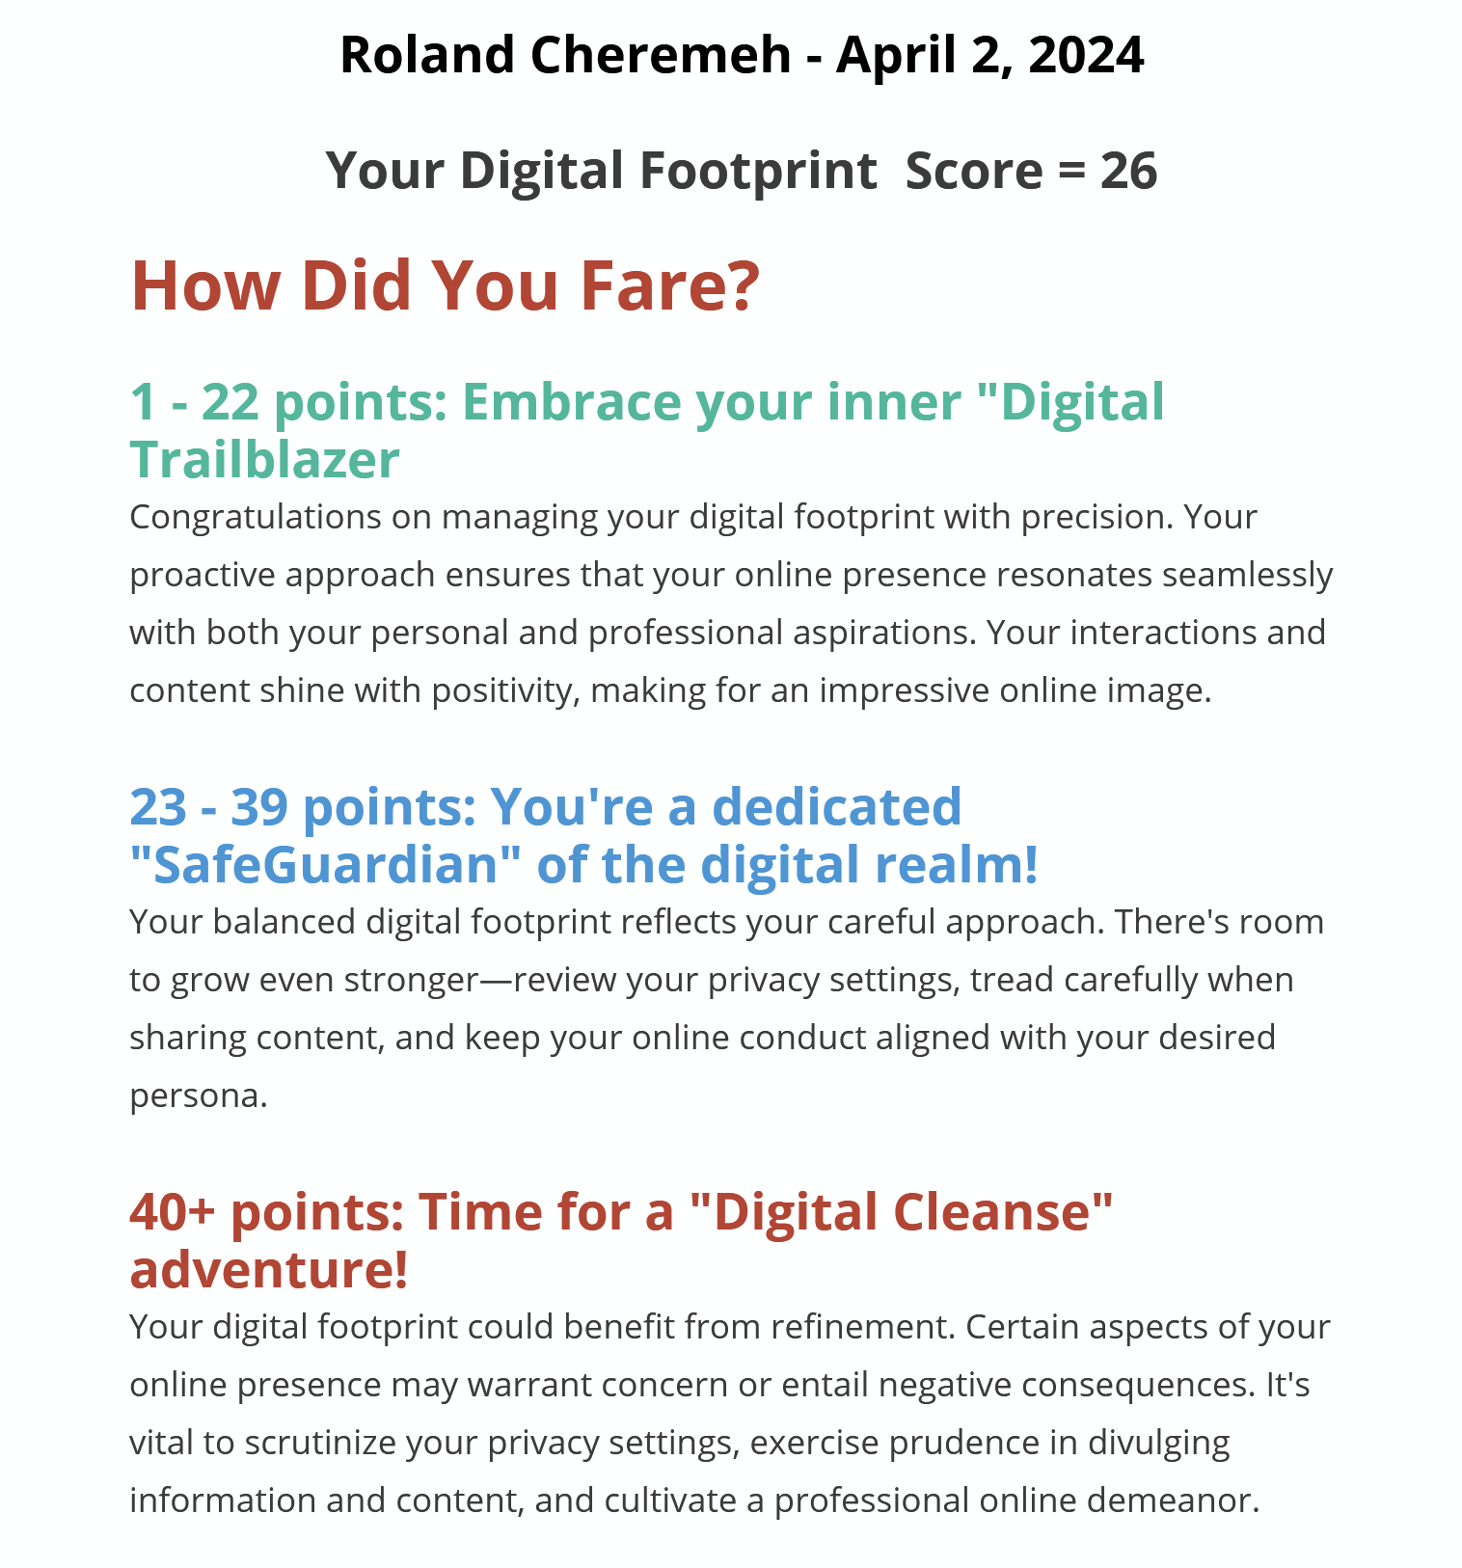

* + 1. How do you feel about your digital footprint after completing this audit? I felt great, and I expected these results. I knew I barely put information about myself out there.
    2. Based on this audit, are there any adjustments you would consider making to your online presence? I will look at my privacy settings a lot more now and continue to keep a lot of posts and who can view my post to people I am friends with only and not accept random friend requests.
    3. In what ways might your digital footprint influence your future personal and professional opportunities? Having a good digital footprint can enhance job opportunities. Recruiters sometimes look at your profile also. Joining educational forums can provide educational learning skills.
    4. What strategies do you plan to implement to manage your digital footprint better going forward? Change my social media password often. Check my privacy settings and read it before agreeing.